Project Title
Near-Duplicate Question Finder
Project Report submitted for the partial fulfilment of grade for the course

Data Structures and Algorithms -3 (25CS2103E)
in

A.Y. 2026-2027

Submitted by
P.Gowtham Varma (2520090202)
A.Siddartha Varma (2520090119)
K.Gireesh Chowdary(2520090215)

Team Number: 4
Section: 13

Under the guidance of
Dr.Dyuti Banerjee

CSIT
Hyderabad-500090, Telangana, India.

K L (Deemed to be) University
DEPARTMENT OF COMPUTER SCIENCE ENGINEERING / COMPUTER SCIENCE AND INFORMATION TECHNOLOGY/ARTIFICIAL INTELLIGENCE & DATA SCIENCE



DECLARATION

The Mini Project Report entitled “Near-Duplicate Question Finder” is a record of Bonafide work of Gowtham-2520090202., siddartha-2520090119., Gireesh-2520090215. , submitted in partial fulfillment for the award of B. Tech in Computer Science and Engineering/Computer Science and Information Technology/ Artifical Intelligence & data Science to the K L University. The results embodied in this report have not been copied from any other departments/University/Institute.

P.Gowtham Varma (2520090202)
A.Siddartha Varma (2520090119)
K.Gireesh Chowdary(2520090215)

K L (Deemed to be) University
DEPARTMENT OF COMPUTER SCIENCE ENGINEERING / COMPUTER SCIENCE AND INFORMATION TECHNOLOGY
CERTIFICATE

This is to certify that the mini project based report entitled “Near-Duplicate Question Finder” is a bonafide work done and submitted by Gowtham-2520090202., Siddartha-2520090119., Gireesh-2520090215. in partial fulfillment of the requirements for the award of the degree of BACHELOR OF TECHNOLOGY in Department of Computer Science Engineering/ Computer Science and Information Technology/Artificial Intelligence & Data Science, K L (Deemed to be University), during the academic year 2026-2027.

Signature of the Supervisor

Signature of the HOD Signature of the External Examiner

ACKNOWLEDGEMENT

The success in this project would not have been possible but for the timely help and guidance rendered by many people. Our wish to express my sincere thanks to all those who has assisted us in one way or the other for the completion of my project.

Our greatest appreciation to my guide, <<Guide Name>>, <<Designation>>, <Department>> which cannot be expressed in words for his/her tremendous support, encouragement and guidance for this project.

We express our gratitude to Dr. P.Venkateshwar Rao (CSE)/Dr. Khaja Shareef (CSIT)/ Dr. Sreenath Itikela (AI&DS), Head of the Department for Computer Science Engineering/ Department for Computer Science and Information Technology/Department of Artificial Intelligence and Data Science for providing us with adequate facilities, ways and means by which we are able to complete this project-based Lab.

We thank all the members of teaching and non-teaching staff members, and also who have assisted me directly or indirectly for successful completion of this project. Finally, I sincerely thank my parents, friends and classmates for their kind help and cooperation during my work.

P.Gowtham Varma (2520090202)
A.Siddartha Varma (2520090119)
K.Gireesh Chowdary(2520090215)

TABLE OF CONTENTS

S.No. | Contents | Page no.
1. | Abstract | 6
2. | Introduction | 7
3. | Literature survey | 8
4. | Problem Statement and Objectives | 10
5. | Hardware and Software requirements | 11
6. | Implementation | 12
7. | Results & Discussion | 14
8. | Conclusion & Future Scope | 18
9. | References | 19

1.ABSTRACT

Online question-and-answer platforms accumulate large numbers of questions that ask the same thing in different words, which splits answers, wastes effort and hurts search quality. This project presents the Near-Duplicate Question Finder, a system that detects such questions efficiently using data-structure and algorithm techniques instead of comparing every pair of questions. Each question is normalised, stripped of stop words and converted into overlapping token 3-grams called shingles. Every shingle is hashed with two independent polynomial hash functions, and the pair of hash values is used to build a 60-value MinHash signature that approximates the Jaccard similarity of the shingle sets. Locality-sensitive hashing (LSH) places similar signatures into the same buckets, so that only questions sharing a bucket become candidate pairs. Each candidate is then confirmed by an exact verification step that combines a dynamic-programming longest-common-substring computation with token-level Jaccard similarity. The algorithms are implemented in Python and delivered as a Flask web application that can compare two questions live or analyse an uploaded CSV/Excel dataset, display the duplicate pairs, report precision, recall and F1 on labelled data, and export the results. On the built-in demo of eight questions the system found all three true duplicate pairs, and on a 12-pair labelled sample it reached a precision of 0.875, a recall of 1.0 and an F1 score of 0.933.
Team Name:
Near-Duplicate Question Finder Team

Team Logo (if any):

Team Members:
- P.Gowtham Varma (2520090202)
- A.Siddartha Varma (2520090119)
- K.Gireesh Chowdary(2520090215)
- INTRODUCTION

Community question-answering sites, help desks and learning portals receive thousands of new questions every day. Many of them are repeats of an existing question written with different words, for example “How can I learn Python programming?” and “What is the best way to learn Python programming?”. Such near-duplicates scatter the answers over several threads, make search results noisy and force moderators to merge questions by hand.
What: This project builds a Near-Duplicate Question Finder that automatically reports pairs of questions that are very likely to mean the same thing. Why: Comparing every question with every other question needs n(n−1)/2 comparisons, which is impractical for large collections, and each comparison itself costs O(m·n) time when exact string matching is used. How: the system first reduces every question to a short numeric signature, uses locality-sensitive hashing to find only the promising pairs, and finally runs an exact check on that small candidate set.
The solution combines several topics from the Data Structures and Algorithms course: hashing (polynomial and double hashing), sets and dictionaries for shingles and buckets, dynamic programming for the longest common substring, and complexity analysis to justify the design. The algorithm is written in Python (main.py) and exposed through a Flask web interface (app.py, templates and static files) so that it can be demonstrated and used without any command-line knowledge.
The rest of this report is organised as follows: Section 3 reviews related work, Section 4 states the problem and objectives, Section 5 lists the hardware and software requirements, Section 6 explains the implementation with code of the main modules, Section 7 presents results with screenshots and discussion, Section 8 gives the conclusion and future scope, and Section 9 lists the references.
- LITERATURE SURVEY
A study of earlier work on near-duplicate detection and similarity search showed ten relevant research papers, books, datasets and tools. Their main ideas and their relation to this project are summarised below.
1. Broder – Resemblance and containment of documents (1997). Andrei Broder introduced shingling, in which a document is represented by the set of its contiguous word sequences, and defined the resemblance of two documents as the Jaccard similarity of their shingle sets. He used min-wise sampling to shrink each set to a small sketch, and the method was used to cluster near-duplicate web pages in the AltaVista search engine. Our project applies the same idea to short questions with token 3-grams.
2. Indyk and Motwani – Locality-sensitive hashing (1998). The authors proposed locality-sensitive hashing for approximate nearest-neighbour search: hash functions are chosen so that similar items collide with high probability and dissimilar items rarely collide. This turns similarity search into hash-table lookup and avoids the all-pairs comparison. The banding technique used in our LSH stage is a direct application of this framework.
3. Broder, Charikar, Frieze and Mitzenmacher – Min-wise independent permutations (2000). This paper gives the theory behind MinHash: for a random permutation, the probability that two sets have the same minimum element equals their Jaccard similarity. Repeating the experiment with many hash functions yields a fixed-length signature whose agreement rate estimates similarity. Our 60-value signature follows this principle with universal hash functions instead of true permutations.
4. Charikar – Similarity estimation techniques from rounding algorithms (2002). Moses Charikar described random-hyperplane hashing, which later became known as SimHash, to estimate cosine similarity with short bit fingerprints. It is an alternative to MinHash that is well suited to weighted features. We reviewed it as a possible future replacement for the MinHash stage.
5. Henzinger – Finding near-duplicate web pages: a large-scale evaluation (2006). Monika Henzinger compared Broder’s shingling and Charikar’s SimHash on a collection of about 1.6 billion web pages. She found that each algorithm works well for different kinds of duplicates, and that combining them improves precision. The study motivated our two-stage design, in which a cheap filter is followed by a stricter verification step.
6. Manku, Jain and Das Sarma – Detecting near-duplicates for web crawling (2007). This Google paper describes how 64-bit SimHash fingerprints and a Hamming-distance threshold are used to find near-duplicate pages among billions of crawled documents. It shows how fingerprint tables can be organised for fast lookup. It demonstrates that near-duplicate detection is needed at production scale, which supports the motivation of our project.
7. Rajaraman and Ullman – Mining of Massive Datasets, Chapter 3 (Finding Similar Items). This textbook chapter explains the complete pipeline of shingling, MinHash signatures and LSH with banding, and gives the formula 1 − (1 − s^r)^b for the probability that a pair of similarity s becomes a candidate when b bands of r rows are used. Our implementation and the discussion of band and row settings follow this chapter.
8. Quora Question Pairs dataset (Kaggle, 2017). Quora released more than 400,000 question pairs labelled as duplicate or not duplicate, and hosted a competition to predict the label. Winning approaches used TF-IDF features, gradient boosting and siamese neural networks. The dataset has the same format (question1, question2, is_duplicate) that our web application accepts, so it can be used for evaluation.
9. Karp and Rabin – Efficient randomized pattern-matching algorithms (1987). Karp and Rabin introduced fingerprinting of strings by polynomial hashing modulo a prime, which allows fast and reliable string comparison. Our hash function h = (h × base + character) mod prime is of this type, and two different bases and primes are used to reduce collisions.
10. datasketch – Python library for MinHash and LSH. datasketch is an open-source library that implements MinHash, weighted MinHash and LSH indexes for large-scale similarity search in Python. It is a practical reference for the same techniques. In our project the stages are written from scratch so that every step of the algorithm is visible and can be explained.
- Problem Statement and Objectives

Problem Statement: A clear and specific articulation of the problem, outlining its importance.
Efficiently detect near-duplicate questions in a large question collection without comparing every pair, while keeping the results accurate.

Problem Description: A concise explanation of the issue or challenge that needs to be solved.
Questions that mean the same thing are often worded differently, so exact matching fails, and brute-force comparison of all pairs grows quadratically with the number of questions.
Objectives:
Identify the Project's Purpose:
The project was started to reduce the manual effort of finding repeated questions on question-and-answer platforms. The objectives of the project are:
- To represent each question as a set of token k-gram shingles after normalisation and stop-word removal.
- To apply double polynomial hashing and MinHash to create compact 60-value signatures that approximate Jaccard similarity.
- To use locality-sensitive hashing so that only similar-looking questions are compared instead of all n(n−1)/2 pairs.
- To verify candidate pairs exactly using the longest common token substring (dynamic programming) and Jaccard similarity.
- To build a web application for comparing two questions, analysing CSV/Excel datasets and downloading the results.
- To evaluate the system with precision, recall and F1 score on labelled question pairs.
- HARDWARE AND SOFTWARE REQUIREMENTS
Hardware Requirements:
- Processor: Intel Core i3 / AMD Ryzen 3 or higher (dual-core, 2 GHz or above)
- RAM: minimum 4 GB (8 GB recommended for large datasets)
- Storage: 500 MB of free disk space for the project, dataset and result files
- Display and input: standard monitor, keyboard and mouse; internet connection only for installing packages
Software Requirements:
- Operating system: Windows 10/11 (also works on Linux and macOS)
- Programming language: Python 3.9 or later
- Libraries: Flask, pandas, openpyxl and Werkzeug (listed in requirements.txt); re, math, argparse and collections from the standard library
- Front end: HTML5, CSS3 and JavaScript (fetch API)
- Tools: Visual Studio Code, PowerShell/terminal, and Google Chrome or Microsoft Edge as the browser
- IMPLEMENTATION

The project has two Python files. main.py contains the algorithm and app.py contains the Flask web layer. The four core modules of main.py are shown below.
Module 1: Preprocessing and k-gram shingling
Normalises the text, removes stop words and creates overlapping 3-token shingles.
STOP_WORDS = {"a","an","the","is","are","am","was","were","be","been",
"being","to","of","in","on","for","with","and","or","as","at","by",
"from","this","that","these","those","it","its","i","we","you","he",
"she","they","my","your","our","their"}

def preprocess(text: str) -> str:
text = str(text).lower()
text = re.sub(r"[^a-z0-9\s]", " ", text)
tokens = [t for t in text.split() if t not in STOP_WORDS]
return " ".join(tokens)

def tokenize(text: str):
return preprocess(text).split()

def make_shingles(tokens, k=3):
"""Overlapping token k-grams."""
if len(tokens) < k:
return {" ".join(tokens)} if tokens else set()
return {" ".join(tokens[i:i+k]) for i in range(len(tokens)-k+1)}
Module 2: Double polynomial hashing and MinHash signature
Hashes each shingle with two polynomial hashes and combines them into 60 hash functions to build the signature.
MOD1, MOD2 = 1_000_000_007, 1_000_000_009
BASE1, BASE2 = 911382323, 972663749

def polynomial_hash(text, base, mod):
h = 0
for ch in text:
h = (h * base + ord(ch)) % mod
return h

def double_hash(shingle):
return (polynomial_hash(shingle, BASE1, MOD1),
polynomial_hash(shingle, BASE2, MOD2))

def minhash_signature(shingles, num_hashes=60):
if not shingles:
return [0] * num_hashes
signature = [MOD1 - 1] * num_hashes
for shingle in shingles:
h1, h2 = double_hash(shingle)
for i in range(num_hashes):
a = (i * 2 + 1) * 104729 + 17
b = (i * 3 + 1) * 130363 + 31
c = i * i + 97
value = (a * h1 + b * h2 + c) % MOD1
if value < signature[i]:
signature[i] = value
return signature
Module 3: LSH banding and candidate generation
Splits each signature into bands, buckets the questions and creates candidate pairs from shared buckets.
def lsh_candidates(signatures, bands=60, rows=1):
buckets = defaultdict(list)
candidates = set()
total = bands * rows
for qid, sig in signatures.items():
padded = sig + [0] * max(0, total - len(sig))
for band in range(bands):
start = band * rows
band_values = tuple(padded[start:start+rows])
buckets[(band, hash(band_values))].append(qid)
for ids in buckets.values():
if len(ids) > 1:
for i in range(len(ids)):
for j in range(i + 1, len(ids)):
candidates.add(tuple(sorted((ids[i], ids[j]))))
return candidates
Module 4: Exact verification (longest common substring + Jaccard)
Confirms a candidate pair using dynamic programming and set similarity.
def jaccard_similarity(set_a, set_b):
union = set_a | set_b
return len(set_a & set_b) / len(union) if union else 0.0

def longest_common_substring_length(tokens_a, tokens_b):
"""Dynamic programming, O(m*n) time and O(n) space."""
if not tokens_a or not tokens_b:
return 0
prev = [0] * (len(tokens_b) + 1)
best = 0
for a in tokens_a:
curr = [0] * (len(tokens_b) + 1)
for j, b in enumerate(tokens_b, start=1):
if a == b:
curr[j] = prev[j - 1] + 1
best = max(best, curr[j])
prev = curr
return best

def exact_verify(tokens_a, tokens_b, min_common_tokens=3, min_jaccard=0.50):
lcs_len = longest_common_substring_length(tokens_a, tokens_b)
jac = jaccard_similarity(set(tokens_a), set(tokens_b))
coverage = lcs_len / max(1, min(len(tokens_a), len(tokens_b)))
duplicate = (lcs_len >= min_common_tokens and
(coverage >= 0.50 or jac >= min_jaccard))
return duplicate, lcs_len, coverage, jac
The Flask layer exposes /api/compare (compare two questions), /api/upload (analyse a CSV/Excel dataset and return duplicates and metrics) and /download/<name> (download the result files). The NearDuplicateFinder class in main.py connects the modules: fit() builds tokens, shingles and signatures, find_candidates() runs LSH, and verify_candidates() applies exact_verify() to every candidate pair.

- RESULTS & DISCUSSION
The application was run locally at http://127.0.0.1:5000 and tested with the built-in demo questions and a 12-pair labelled sample dataset (sample_questions.csv). The screenshots below show the main screens with a short explanation of each.
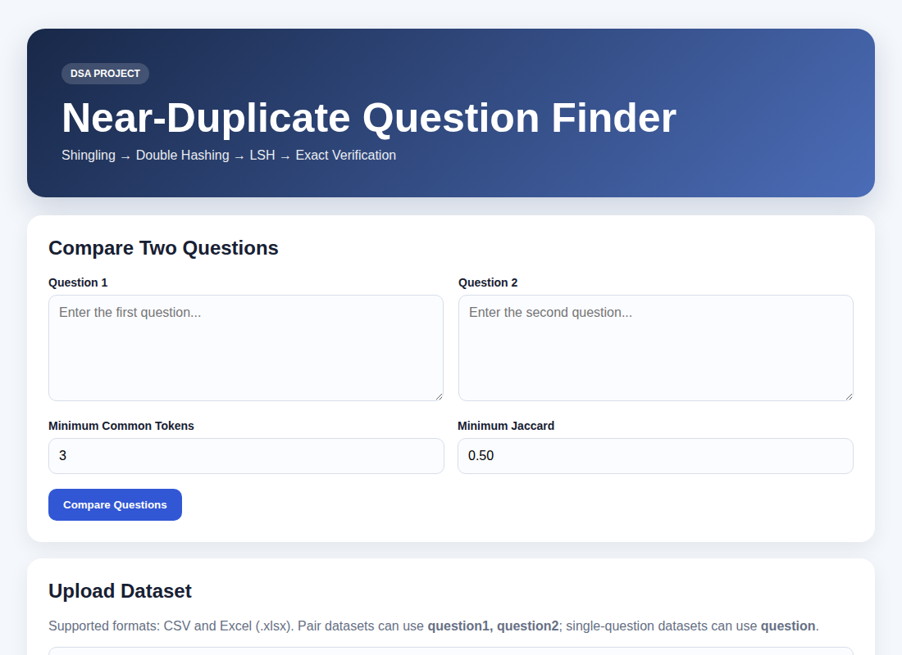
Figure 1: Home page of the web application.
The home page offers a two-question comparison tool and a dataset upload form. Thresholds (minimum common tokens, minimum Jaccard, shingle size k) can be changed.
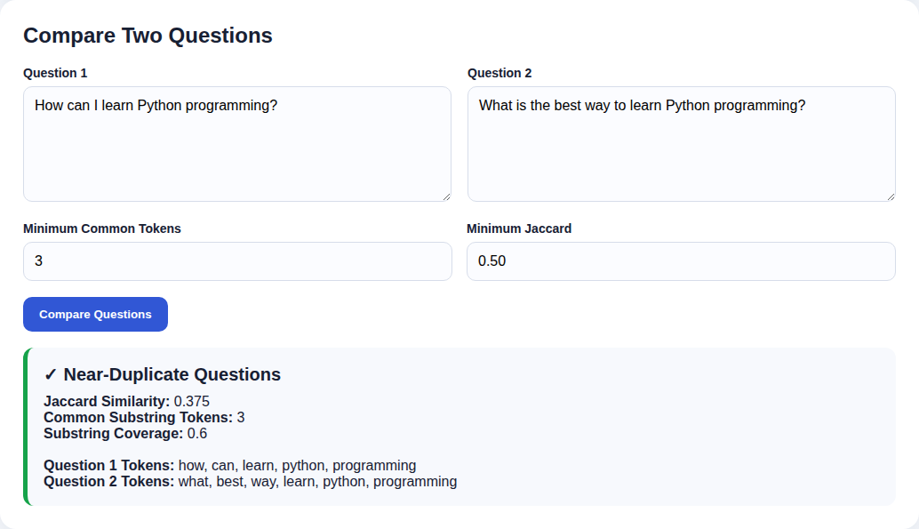
Figure 2: Comparing two similar questions.
The pair “How can I learn Python programming?” and “What is the best way to learn Python programming?” is reported as a near-duplicate. The result shows Jaccard 0.375, 3 common tokens and 0.6 coverage.
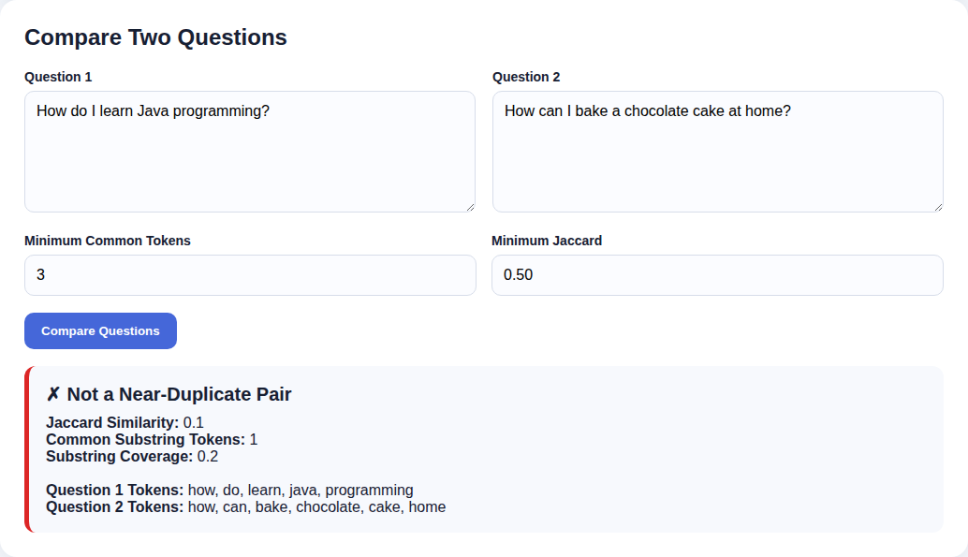
Figure 3: Comparing two unrelated questions.
A Java learning question and a cake-baking question share no common token sequence. The system reports “Not a Near-Duplicate Pair”.
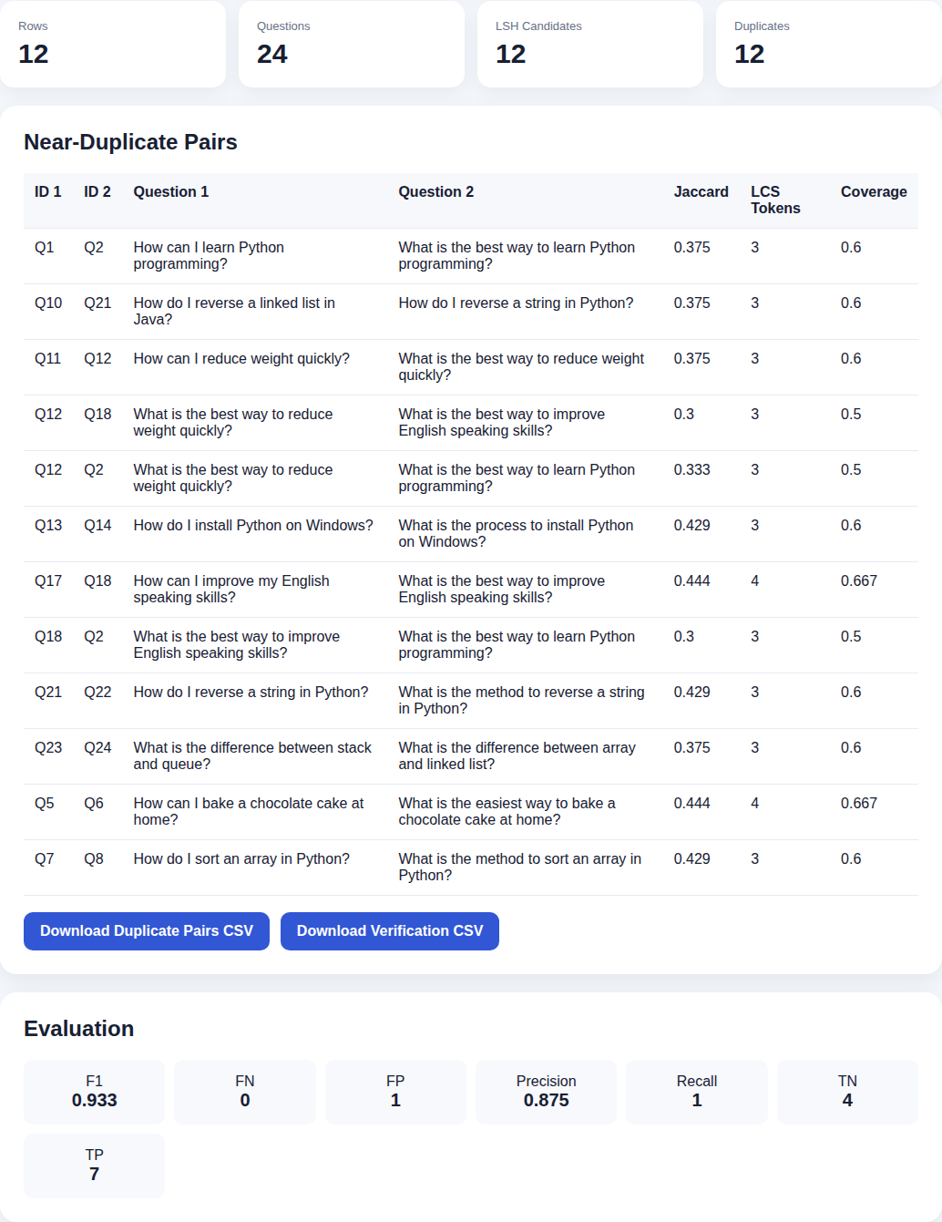
Figure 4: Dataset analysis dashboard.
After uploading the 12-pair CSV, the page shows 12 rows, 24 questions, 12 LSH candidates, 12 verified pairs and the evaluation. The duplicate pairs can be downloaded as CSV files.
Results of the built-in demo (8 questions)
Pair | Topic | Jaccard | LCS tokens | Coverage | Verdict
Q1 – Q2 | Learn Python | 0.375 | 3 | 0.600 | Duplicate
Q5 – Q6 | Bake chocolate cake | 0.444 | 4 | 0.667 | Duplicate
Q7 – Q8 | Sort array in Python | 0.429 | 3 | 0.600 | Duplicate
Evaluation on the 12-pair labelled sample
TP | TN | FP | FN | Precision | Recall | F1
7 | 4 | 1 | 0 | 0.875 | 1.000 | 0.933
Discussion. In the demo, only 3 of the 28 possible question pairs became LSH candidates, and all three were confirmed as true duplicates, while the Java/Python “learn programming” questions were correctly kept apart because they do not share a three-token run. On the 12-pair sample, all 7 labelled duplicates were found (recall 1.0). One labelled non-duplicate (“difference between stack and queue” vs “difference between array and linked list”) was accepted as a duplicate because the two questions share the phrase “what difference between”, which gives a false positive and lowers precision to 0.875.
The dataset run also reported a few extra pairs from different rows that share generic phrases such as “what best way”. This shows that the method is purely lexical: common question words can make unrelated questions look similar, and paraphrases with different vocabulary can be missed. Raising the minimum common tokens, adding question words to the stop-word list, or using a stronger band/row setting would reduce these errors. Because the evaluation function applies the verification rule directly to the labelled pairs, the reported precision, recall and F1 describe the verification stage; the effect of the LSH filter is visible in the candidate counts.
- CONCLUSION & FUTURE SCOPE
The project achieved its objectives. A complete pipeline of preprocessing, shingling, double polynomial hashing, MinHash, LSH and exact verification was implemented, and it correctly found the near-duplicate question pairs in the demo while keeping similar-topic but different questions apart. The LSH stage reduces the number of pairs that need the expensive O(m·n) verification, and the Flask web application makes the system easy to use for comparing two questions or analysing CSV/Excel datasets with downloadable results and precision, recall and F1 metrics. The experiments also showed that the lexical approach can produce false positives from shared generic phrases and cannot recognise synonyms.
Future scope
- Near term: use a sharper LSH setting such as 20 bands × 3 rows, extend the stop-word list with question words, remove empty questions before processing, and evaluate the full pipeline (including LSH recall) on the Quora Question Pairs dataset. Add paging for large result tables and per-user result files in the web application.
- Medium term: add synonym and stemming support or word-embedding similarity as a second stage, support weighted shingles and SimHash as an alternative signature, and add automated unit tests and a REST API for integration with other applications.
- Long term: use sentence-embedding models with approximate nearest-neighbour indexes for semantic duplicate detection, support multiple languages, run the pipeline as a streaming service that checks each new question when it is posted, and deploy it on a production server.
- REFERENCES
[1] A. Z. Broder, “On the resemblance and containment of documents,” Proc. Compression and Complexity of Sequences, IEEE, 1997. doi:10.1109/SEQUEN.1997.666900
[2] P. Indyk and R. Motwani, “Approximate nearest neighbors: towards removing the curse of dimensionality,” Proc. ACM STOC, 1998. doi:10.1145/276698.276876
[3] A. Z. Broder, M. Charikar, A. M. Frieze and M. Mitzenmacher, “Min-wise independent permutations,” Journal of Computer and System Sciences, vol. 60, no. 3, 2000.
[4] M. S. Charikar, “Similarity estimation techniques from rounding algorithms,” Proc. ACM STOC, 2002. doi:10.1145/509907.509965
[5] M. Henzinger, “Finding near-duplicate web pages: a large-scale evaluation of algorithms,” Proc. ACM SIGIR, 2006. doi:10.1145/1148170.1148222
[6] G. S. Manku, A. Jain and A. Das Sarma, “Detecting near-duplicates for web crawling,” Proc. WWW, 2007. doi:10.1145/1242572.1242592
[7] J. Leskovec, A. Rajaraman and J. Ullman, Mining of Massive Datasets, Chapter 3: Finding Similar Items. http://www.mmds.org
[8] Quora Question Pairs, Kaggle competition dataset. https://www.kaggle.com/c/quora-question-pairs
[9] R. M. Karp and M. O. Rabin, “Efficient randomized pattern-matching algorithms,” IBM Journal of Research and Development, 31(2), 1987. doi:10.1147/rd.312.0249
[10] datasketch: MinHash, LSH and probabilistic data structures for Python. https://github.com/ekzhu/datasketch

